Onchron - eDelivery Installation Guide

TABLE OF CONTENTS

PURPOSE 3

ACRONYMS, ABBREVIATIONS, DEFINITIONS 3

ACCESS 3

COMPONENTS 3

PRE-REQUISITES 4

FLEXERA DEPLOYMENT 9

VERIFICATION POST INSTALLATION 28

DEPLOYED PACKAGE AVAILABLE IN IRIS 28

REVISION HISTORY 33

## PURPOSE

The purpose of this document is to provide the steps to install the Onchron service onto EHL 2.0 platform through IRIS.

## ACRONYMS, ABBREVIATIONS, DEFINITIONS

|  |  |
| --- | --- |
| EHL | Edison Health Link |
| IRIS | Imaging Remote Installer of Software |

## ACCESS

|  |
| --- |
| Access needed: |
| • Content Manager  • Entitlement Manager  • Service Admin |
| Trainings required: |
| • GEHC eDelivery Design Transfer Guidance, GEHC-DIG-180828-003945_CURR  • eDelivery Service Admin Training, GEDIG-HC-180618-004623_CURR  • GEHC eDelivery Entitlement Management Guidance, GEHC-DPS-Technology-190219-005031_CURR  For access request check: eDelivery_Request_Portal_Access.pdf |

## COMPONENTS

| **Component** | **Version** | **Download Location** |
| --- | --- | --- |
| onchron | *X.Y.Z* | *ISO:* <https://hc-eu-west-aws-artifactory.cloud.health.ge.com/artifactory/generic-eis-snapshot/oncology-digital-budapest/onchron/(Select> Required ISO and PackageMetaData Version) |

## PRE-REQUISITES

1. Download the Package contents(ISO and PackageMetaData) from the Components section into the Engineer’s Laptop.
2. Copy Paste PackageMetaData as Duplicate file.
3. Rename the First PackageMetaData Downloaded in Step1
4. Open the Renamed PackageMetaData Mentioned in Step3 and Update the Package ID then Save.
5. Rename the Second PackageMetaData Dupicated in Step2
6. Open the Renamed PackageMetaData Mentioned in Step5 and Update the Package ID then Save.

**NOTE**: Both Base and Formal PackageMetaData.json file should be renamed as same as "Package ID" mentioned in the json file and must ends with “packagemetadata.json”.

Example:

ISO File - onchron_0.2.1

First PackageMetaData File - onchronbaseiso_0.2.1packagemetadata

Package ID – onchronbaseiso_0.2.1

Second PackageMetaData File - onchronformaliso_0.2.1packagemetadata

Package ID – onchronformaliso_0.2.1

1. Login to admin web console in the browser located at https://{IP}/admin-console-home/ and click on Application 🡪 SiteConfig and Click on the Start configuration to in as shown below:

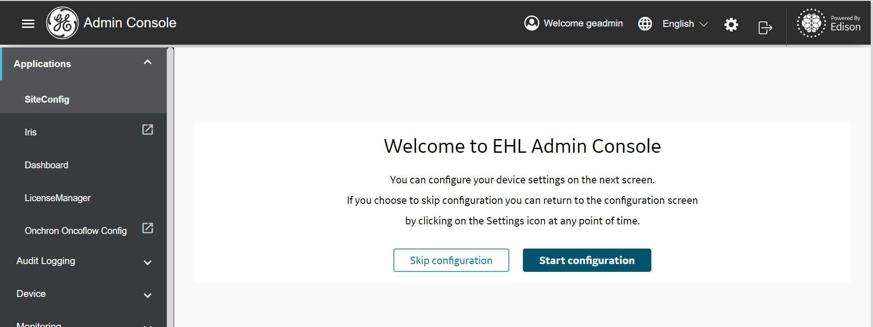

1. Once Clicked the Start configuration should look as follows:

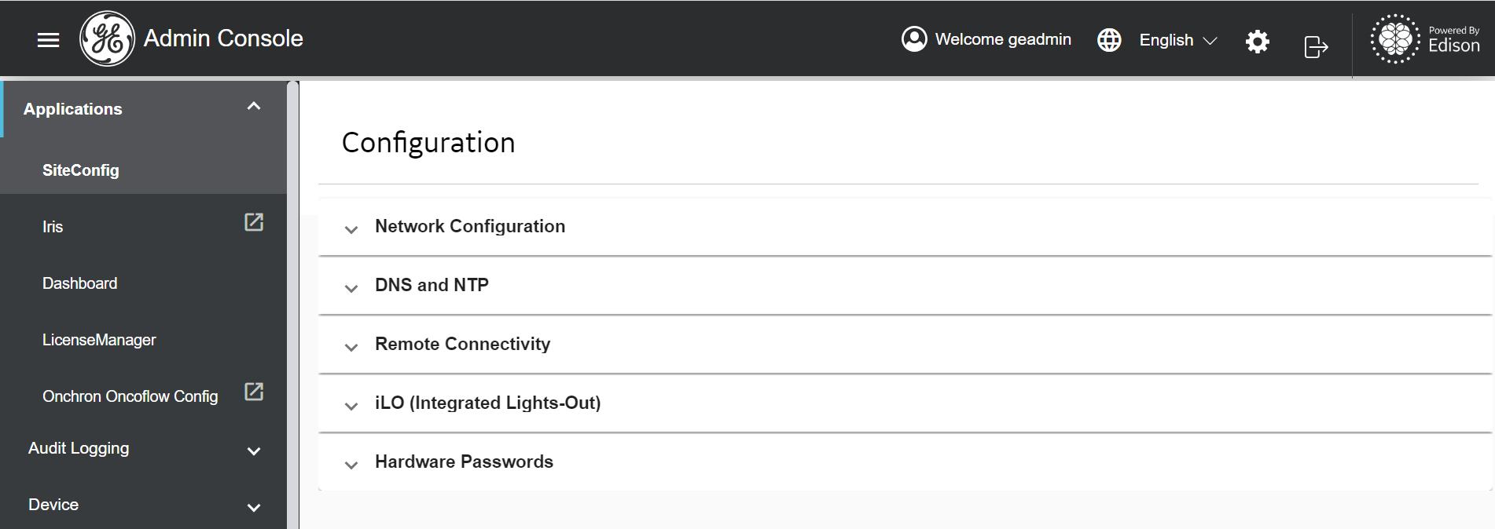

1. Expand the Remote Connectivity -> Dy Default Ent

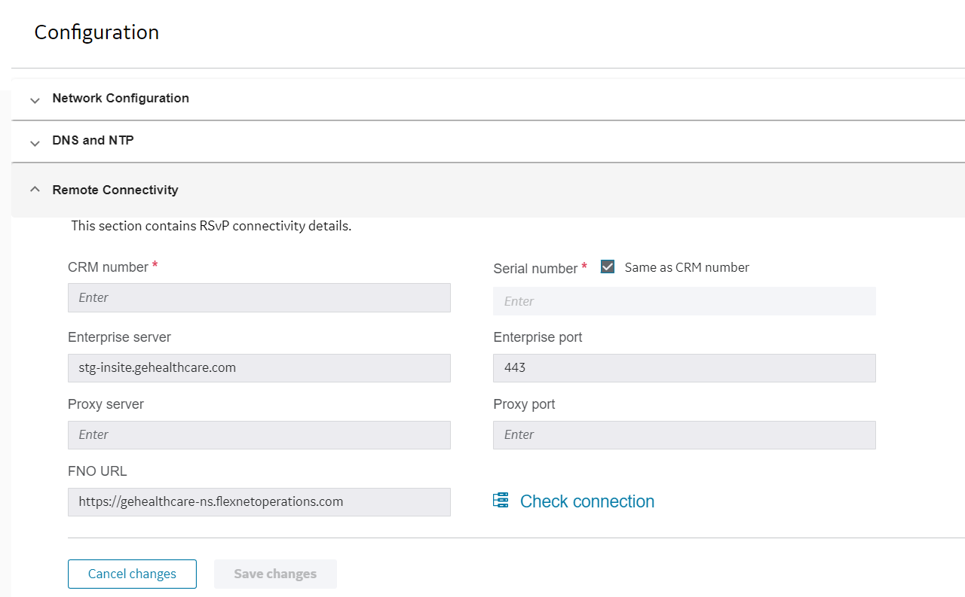

1. Enter Values in CRM number, Proxy server, Proxy port, FNO URL

Example:

CRM number: EDISON_ONCO_DEV4

Proxy server: PITC-Zscaler-Americas-Cincinnati3PR.proxy.corporate.ge.com

Proxy port: 80

FNO URL: <https://gehealthcare-ns-uat.flexnetoperations.com>

1. Click on Save changes then Click on Check connection.

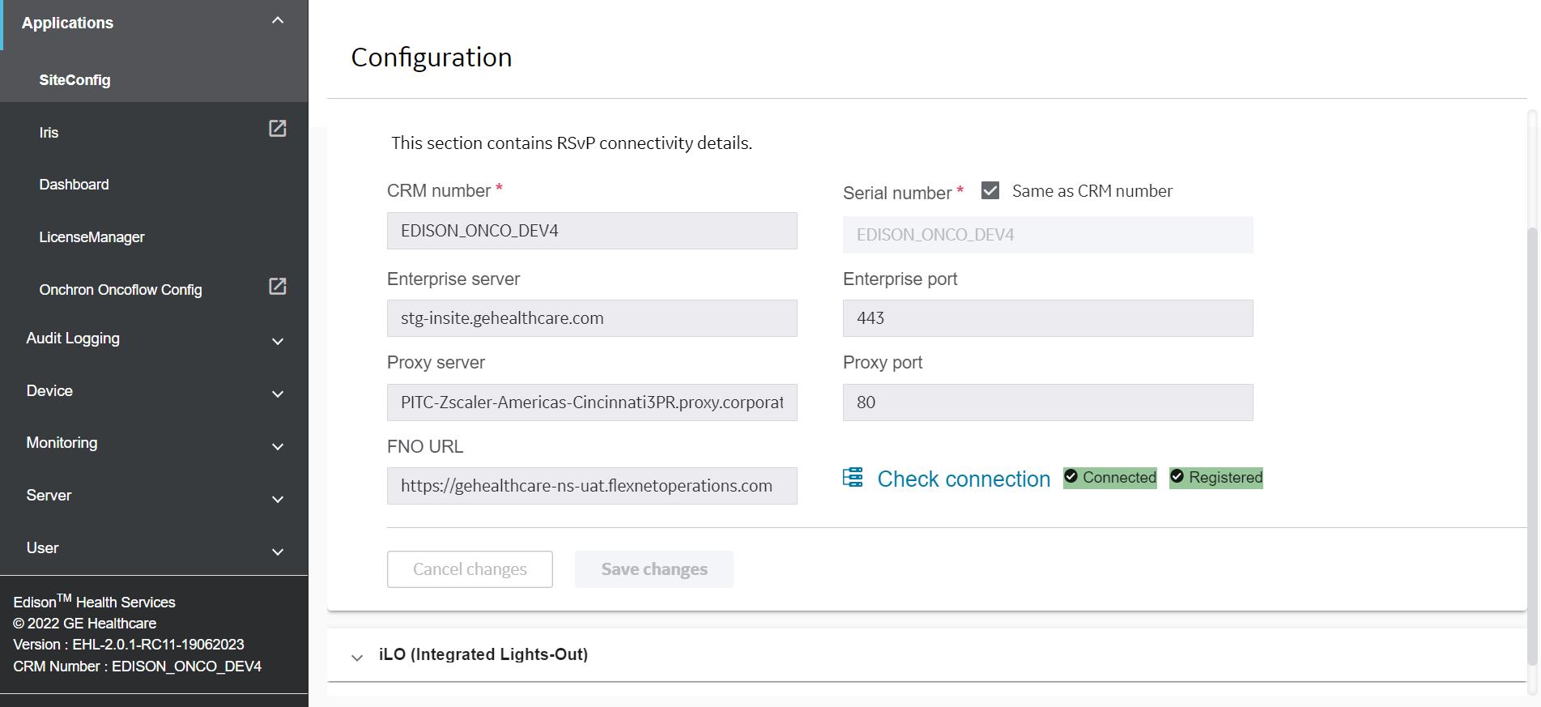

1. Additionally Check : (Not Mandatory) Connect SSH and Confirm the CRM and Registered Status – Yes.



1. Login to Flexera -> Click on Device -> Click on Create Device



1. Enter Name and ID as CRM ID and Click on Save Button

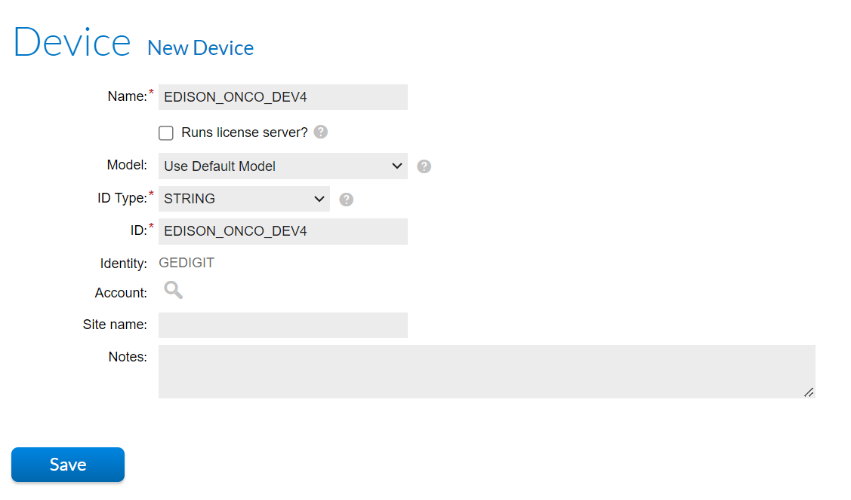

1. Click on Products -> Click on Create Producer (It’s a Optional, Not Mandatory , User can use existing Producer.)

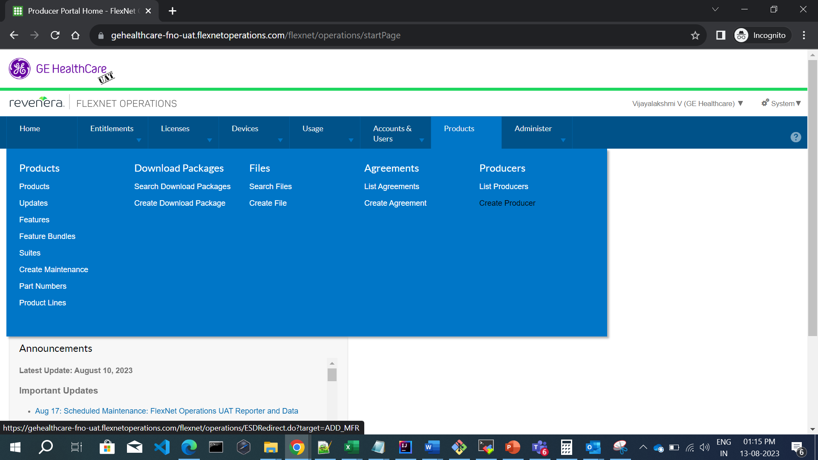

1. Enter Producer ID and Producer Name and Save

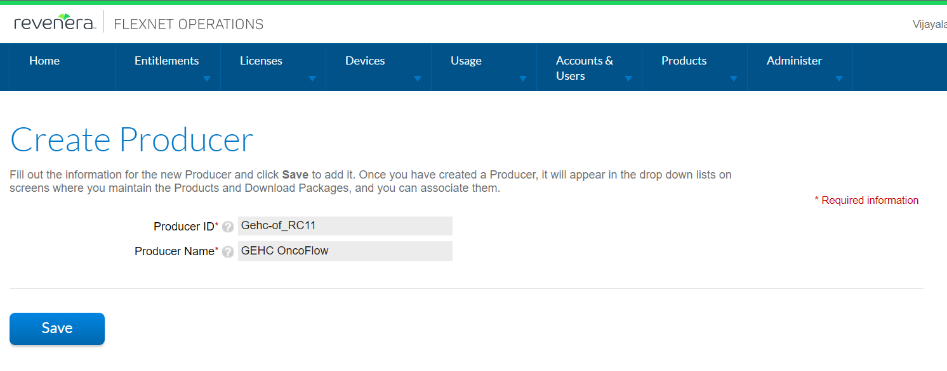

## FLEXERA DEPLOYMENT (eDelivery) INSTRUCTIONS

### CREATE AND UPLOAD FILES

1. Login to Flexera -> Under “Products” menu click “create file”

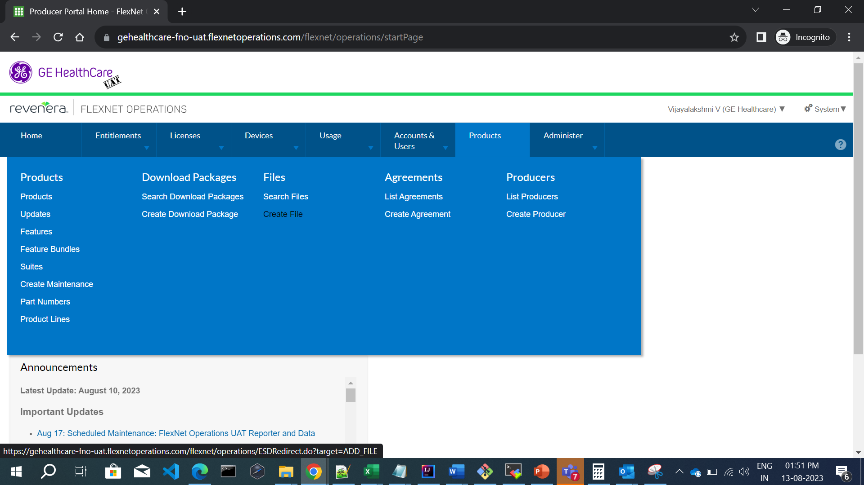

1. Create file for basepackagemetadata.json -> Enter Mandatory Fields, Maintain the File ID format same as mentioned in Prerequisites step6 and Click on Save & upload file.



1. Select Choose File and Upload File (Saved in Prerequisite Step1)



1. Under “Products” menu right click on “search file” -> Enter File ID and confirm the File Status is LOADED.



1. Create file for formalpackagemetadata.json -> Enter Mandatory Fields, Maintain the File ID format same as mentioned in Prerequisites step6 and Click on Save & upload file.



1. Select Choose File and Upload File (Saved in Prerequisite Step1)



1. Under “Products” menu right click on “search file” -> Enter File ID and confirm the File Status is LOADED.

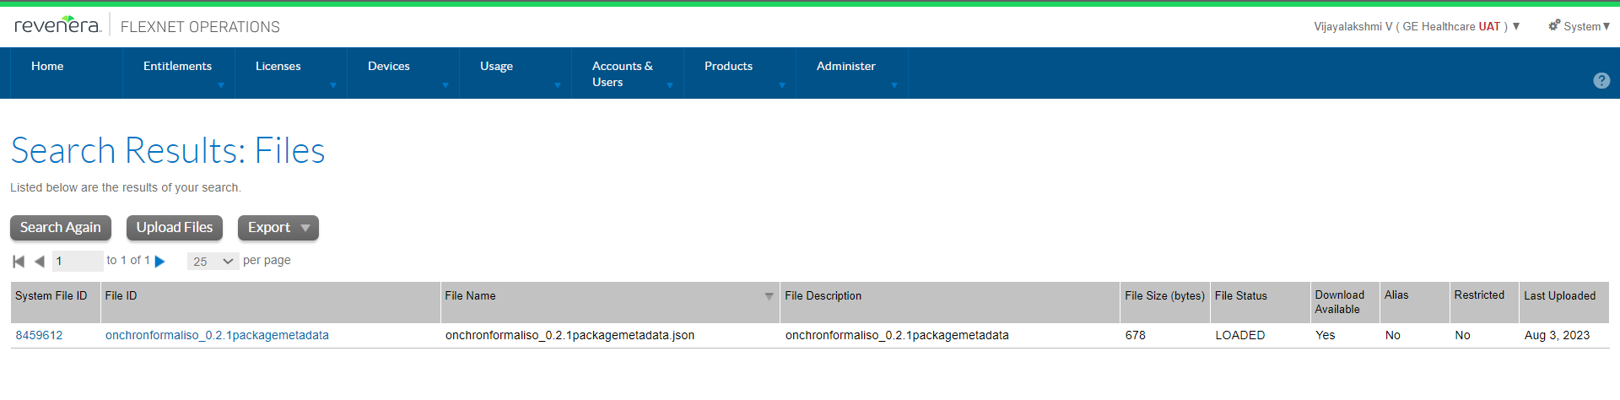

1. Create file for ISO -> Enter Mandatory Fields, Maintain the File ID format same as mentioned in Prerequisites step6 and Click on Save & upload file.



1. Select Choose File and Upload File (Saved in Prerequisite Step1)
2. Under “Products” menu right click on “search file” -> Enter File ID and confirm the File Status is LOADED.

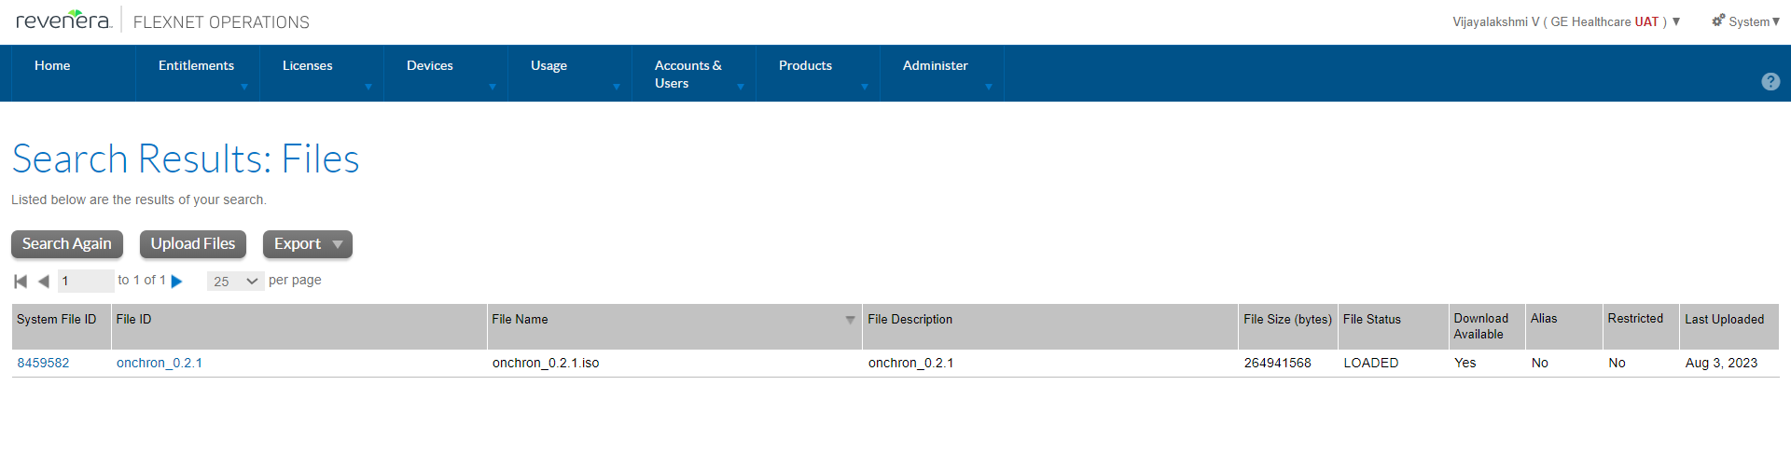

### CREATE DOWNLOAD PACKAGES

1. Under “Products” menu click “Create Download Packages”

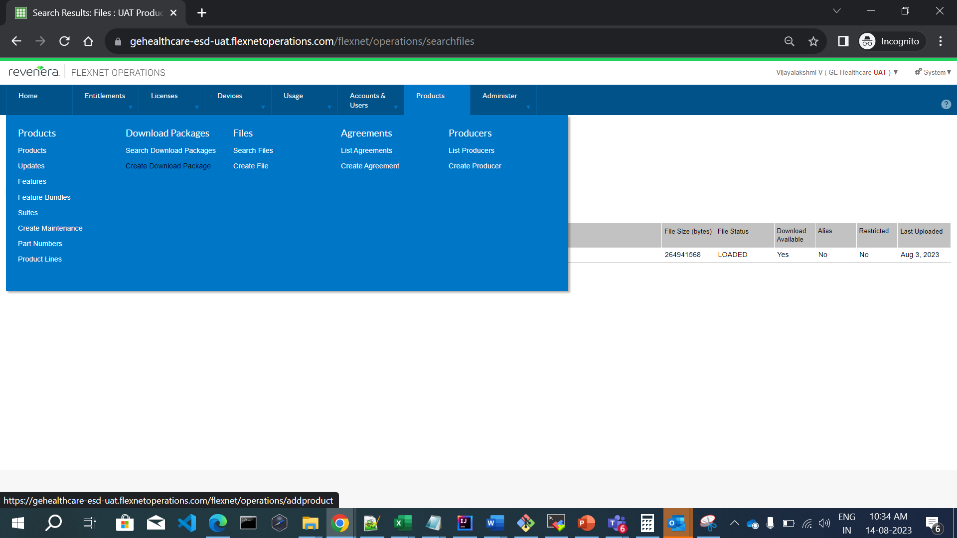

1. In the Create download package screen enter the required information (minimum fields are – download package ID, download package name, version(ex: 1.0), Release group(ex: RelTest1), Expiration date(future date), Download package producer(GEHC Oncoflow), Product line(ALL), End user license agreement(GE Healthcare Agreement), ECCN(EAR99))



1. Click on save.



1. Under “Products” menu click “Search Download Packages”
2. Search for the “onchronbaseiso_0.2.1” and Click on the ID link
3. Click on Associate dropdown and Select Associate files
4. Enter the file id for iso, json and click on Associate files.
5. Under “Products” menu click “Search Download Packages”
6. Search for the “onchronbaseiso_0.2.1” and Click on the ID link
7. Click on Associate dropdown and Select Associate files
8. Enter the file id for iso, json and click on Associate files.



1. Under “Products” menu click “Create Download Packages”
2. In the Create download package screen enter the required information (minimum fields are – download package ID, download package name, version(ex: 2.0), Release group(ex: RelTest2), Expiration date(future date), Download package producer(GEHC Oncoflow), Product line(ALL), End user license agreement(GE Healthcare Agreement), ECCN(EAR99))



1. Click on save.
2. Under “Products” menu click “Search Download Packages”
3. Search for the “onchronformaliso_0.2.1” and Click on the ID link
4. Click on Associate dropdown and Select Associate files
5. Enter the file id for iso, json and click on Associate files.
6. Under “Products” menu click “Search Download Packages”
7. Search for the “onchronformaliso_0.2.1”and Click on the ID link
8. Visually Verify the Associated files are displayed.



### CREATE UPDATES

1. Go to the “Products” menu and select “Updates”

2. In update screen, click on “Create” button

3. In update screen, enter the required information(Name, update id, Start date should be changed to one day before date) on the first Overview tab



4. Go to Release Form, Click on Add

5. In Release Form popup, search the name with base download package name.

6. Select the check box and click on select



7. Go to Release To, Click on Add



8. In Release To popup, search the name with formal download package name

9. Select the radio button, select the platform as Linux-64 and click on select

10. Go to languages, Click on Add

11. Enter Title, Description and click on select



12. Click on Save

### CREATE PRODUCTS

1. Go to the “Products” menu and select “Products”

2. click the “Add new Product” button



3. Enter product name(ex: onchron_ISO), version(ex: 1.0), start date(ex: current date), end date(ex: future date)

4. Scroll down to Additional attributes, click on Add feature button

5. In Add features to product popup, Search for name(ex: GEHC-Default,1.0)

6. Click on search, select the name and click on add

7. Line is added to the feature and Click on save

### ASSOCIATE DOWNLOAD PACKAGE TO THE SELECTED PRODUCTS

1. Go to the “Products” menu and select “Search Download Packages” in new window
2. Search for base download package name and click on the ID link
3. Click on Associate dropdown and Select Associate to product
4. Enter the Product id with Version Number recorded in above step (ex: onchron_ISO::1.0)
5. Click on Search
6. Select the check box and Click on Associate download package to the selected products



1. Go to the “Products” menu and select “Search Download Packages” in new window
2. Search for formal download package name and click on the ID link
3. Click on Associate dropdown and Select Associate to product
4. Enter the Product id with Version Number recorded in above step (ex: onchron_ISO::1.0)
5. Click on Search
6. Select the check box and Click on Associate download package to the selected products



### ASSOCIATED PRODUCT AND DEPLOY

1. Go to the “Products” menu and select “Products” in new window
2. Click on recently accessed product name hyperlink
3. Scroll down to Additional attributes, Click on Download Packages tab
4. Download packages will display with associated download package as line items



1. Click on Next and Click on Link license models
2. In Select license models popup, enter license name(ex: DEMO_UV_LICENSE_MODEL) and search
3. Add to the selected license models and click on Add



1. Scroll down and click on next button



1. In Map part numbers to product screen, click on next button



1. In Relate to different products screen, click on next button
2. In Map product to product line screen, Click search for product line
3. In select product line for product popup, check radio button for "ALL" and click on OK.



1. Click on next button.
2. In Review products, Select the check box
3. In Change state drop down, select deploy
4. Popup will display to deploy, click OK
5. In Deploy products screen, scroll down and click on deploy button -> Products deployed successfully message should be displayed.

### CREATE ACCOUNT

1. Go to “Accounts & Users” menu, click on the “Create Account” in new window
2. Enter required information for Account id (ex: OnchronAccount), Account name(ex: OnchronAccount), Description(ex: Oncoflow Account) to create the account
3. Scroll down and click on Create a user or Link Existing User and Select User.

NOTE: Create a user - one time setup, If already created the user Go for Existing User.



#### Existing User:

1. Click on link existing users

2. Select user popup will open, search with the display name

3. Select the checkbox for name and roles

4. popup will be displayed , click on OK

5. Click on Save button -> Account <Account ID> Successfully edited displayed.

#### New User:

1. If new user Create A User screen, Enter contact details for First name, Last name, Email Address(ex: sso@ge.com)

2. In Additional attributes, enter sso

3. In Account, Select the check box and select roles

4. Click on Save -> Account <Account ID> Successfully edited message displayed.



### CREATE ENTITLEMENTS

1. Go to “Entitlement” menu, click on “create”

2. In create an entitlement screen, scroll to end customer and channel partners

3. Click on Add, popup with Accounts will open, Search Account name

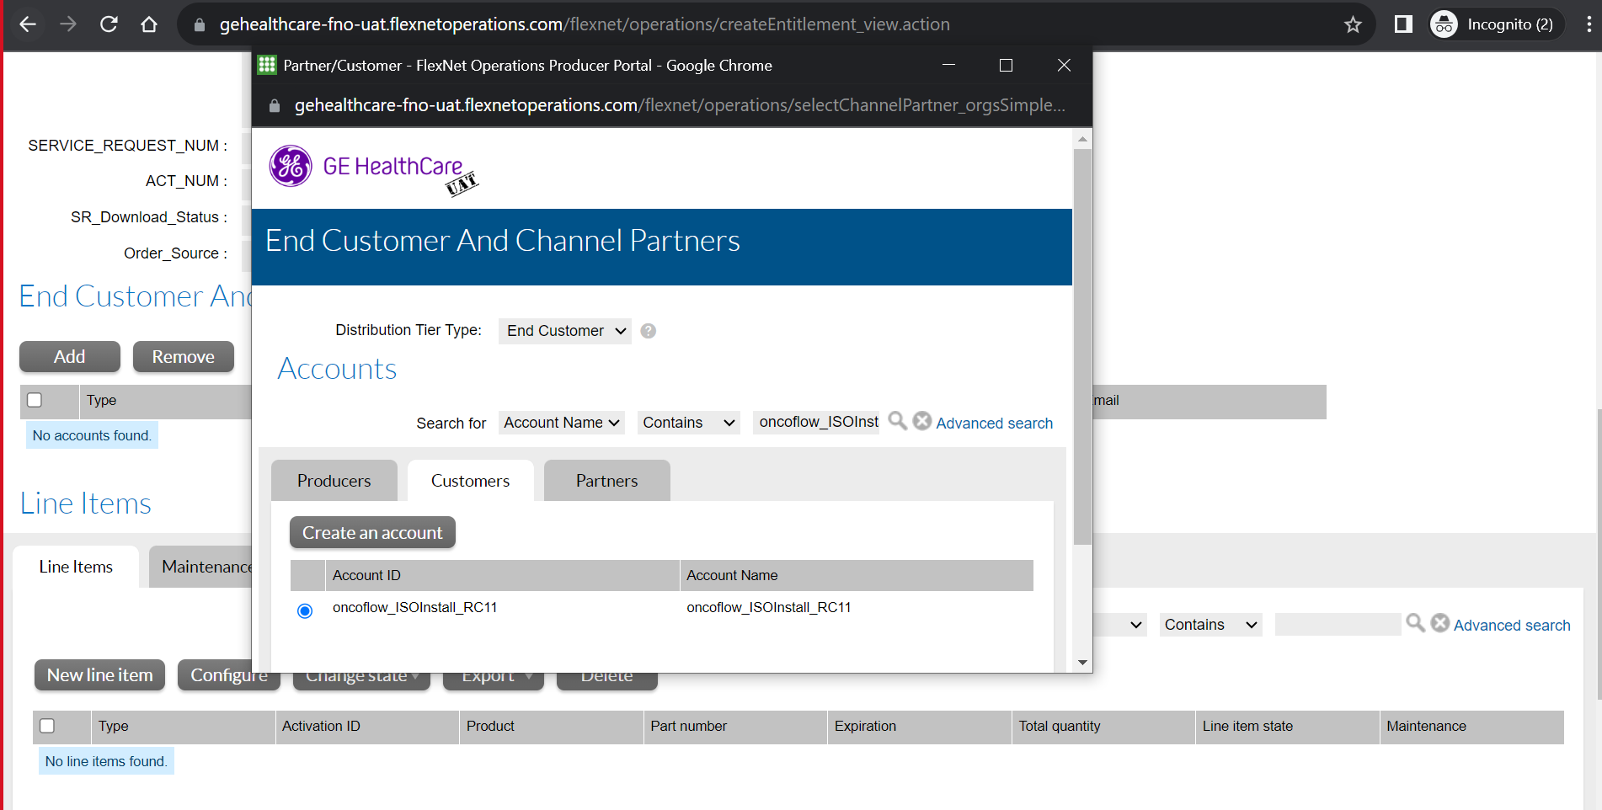

4. Click on the radio button and click Save, End customer is added

5. Scroll down to line items, click on new line item button

6 Configure line item popup will display, Select product and click on next

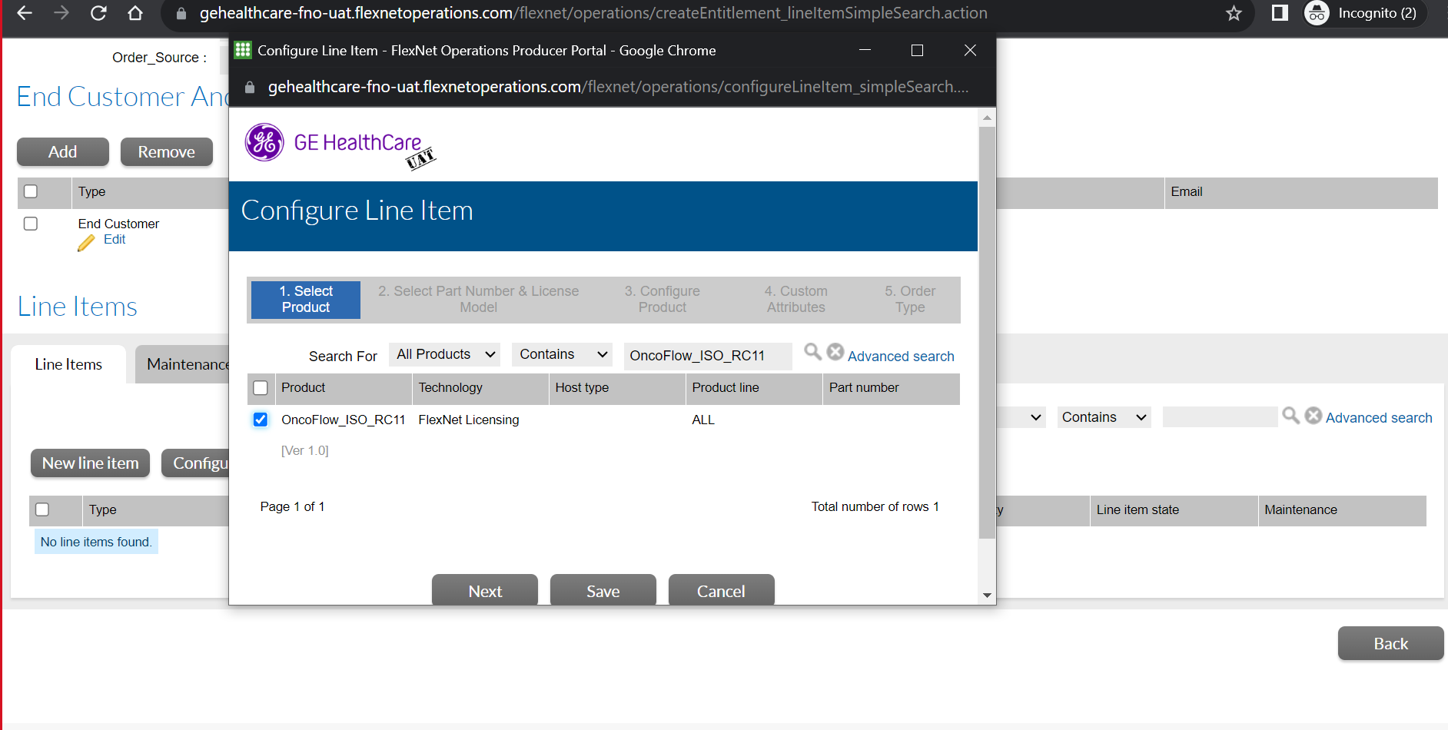

7. In Select part number & license model, click on next

8. In configure product, enter quantity per copy as "100", expiration select "permanent" from dropdown and click on save



9. Line item is added, Select the line item and Click on "Save & deploy" button -> Entitlement deployed successfully will display.

### ASSIGN ACCOUNT AND MAP ENTITLEMENTS

1. Go to “Devices” menu, click on “Devices”

2. In Devices screen, enter device name(ex: EDISON_ONCO_DEV4) and click on search

3. Click on the device

4. For Mapping the account to the device, select the remove licenses from licenses drop down

5. In device details, give the quantity as "1" for the licenses available and click on save

6. Licenses will be removed successfully. In device screen, select the Assign account from edit drop down

7. Search for the Account ID, in the Account popup, search for the Account name(ex: OnchronAccount)

8. Click on the radio button and click save

9. Click on Assign account button

10. Click on Map entitlements in the Licenses dropdown

11. Add quantity as "1" in the Map entitlements screen and Click on Save button -> Entitlements successfully mapped will display.

## VERIFICATION POST DEPLOYMENT

Login to the Setup VM (Not Mandatory) and check if the Deployed Software is available using the below commands.

| **Command** | **Sample Output** |
| --- | --- |
| *SoftwareDownload.py updates* |  |

## DEPLOYED PACKAGE AVAILABLE IN IRIS

1. Login to the Admin console using valid user credentials to check the Oncoflow software is downloaded via edelivery.
2. Navigate to Application → IRIS UI menu tab
3. Click on "Manage" option under Updates section on Software Inventory screen
4. Navigate to Updates tab
5. Select the Package and Click on Download Now



1. Download started in Downloads tab.



1. Select the package want to install and Click on "Install Now" button



1. Acknowledge and click "Proceed" to initiate the precheck process of the Application package install



1. select "Acknowledge" and click "Continue" to install the Application package





1. Package should be installed successfully with Install Status as INSTALLED



11. Click on close and Verify the installed packages in update history tab



12. Go to Server, Select Kubernetes

13. Select namespace as onco to verify all the services running



## REVISION HISTORY

|  |  |  |  |
| --- | --- | --- | --- |
| Rev | Date | Author | Revision Note |
| 01 | 2023-Aug-14 | Vijayalakshmi V | Initial revision for Onchron 1.0.0 |